NJ-03
2016 IE Strategy Memorandum

Updated on 4/18/16

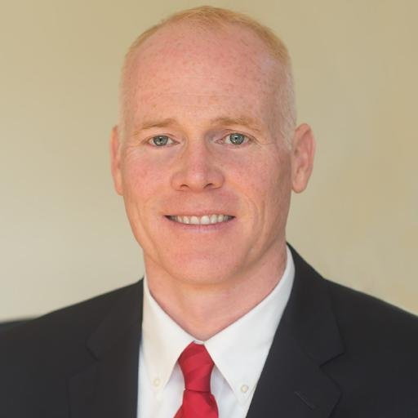



JAMES KEADY TOM MACARTHUR
CoH: CoH: $399,108.66
Date: 4/15/16 Date: 4/15/16
Occupation: Assemblyman Occupation: Congressman
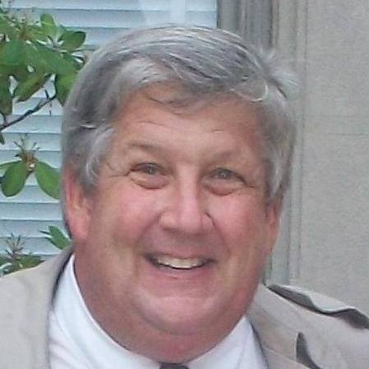

FREDERICK JOHN LAVERGNE
CoH: $600
Date: 4/15/16
Occupation:

SECTION I: Race Overview

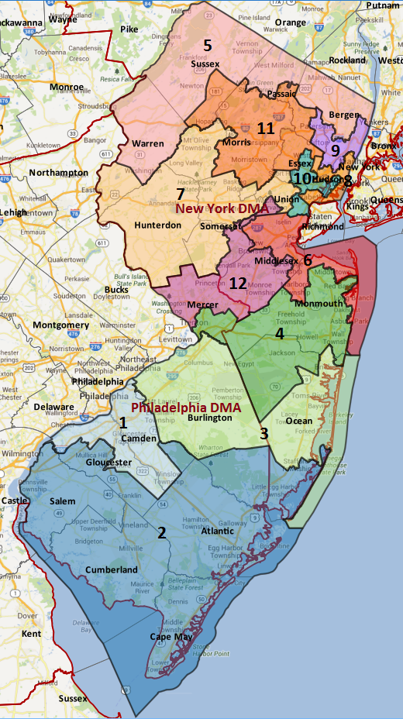

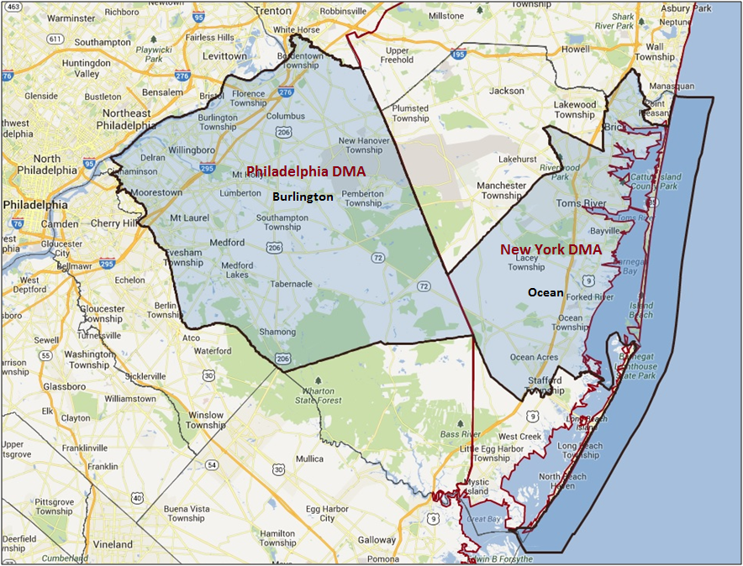

Media Market Costs

TV DMA | % of  CD | I.E.  35+ CPP | Cable CPP
PHILADELPHIA | 56% | $756
NEW YORK CITY | 44% | $2079
NJ-03 TOTALS: | 100.0%
Digital Landscape
  - Persuasion universe size: 50,302
  - Audience extension (key demos): Independents & Democrats
  - Weekly budget for full coverage: $13,631.89
  - Reach
    - YouTube - 356,602
    - Pandora - 211,806

Presidential Statistics
Cycle | Candidate | Party | Vote
2012 | Obama | DEM | 52.3%
2012 | Romney | REP | 47.7%
2008 | Obama | DEM | 51.7%
2008 | McCain | REP | 48.3%

Congressional Statistics
Cycle | W/L | Candidate | Party | Vote
2014 | L | BELGARD | DEM | 45.1%
2014 | W | MACARTHUR | REP | 54.9%
2012 | L | ADLER | DEM | 45.5%
2012 | W | RUNYAN | REP | 54.4%

NCEC Data
Dem Performance: 48%
BVAP: 9.9%
Hispanic: 4.9%
Asian: 2.8%
Total Minority: 17.6%

Critical Dates
Filing Date: May 30th, 2016
Primary Date: June 7th, 2016

Pre-Election Day Voting

Type of  “Early Voting” | Start Date  End Date | Percent of  Vote Cast Using this Method | Brief Description  (where/how  do people vote) | Timeframe (when does the majority of voting happen)
Early Vote | Oct 8 –Nov 8 |  | Voters can bring their early ballots to the board of elections office or be issued a ballot at the office at the time of their visit
VBM Absentee Ballot/In person Absentee | Received by 8pm on Nov 8th |  | Voters must apply for an absentee/VBM ballot via mail, online, or in person

